Application Content Extract Guide
These are the instructions for executing the Deloitte ACTT script for Azure on an Azure Cloud Shell-PowerShell Window. This script will run specific Azure CLI/Azure PowerShell commands and generate several “.JSON/.TXT/.CSV/.LOG” files. These files are plain text files and can be viewed in any text editor/viewer.

Script Security
The script contains read only queries and does not create or update any configuration on Azure. You can and should review the script to obtain comfort over what it is performing. We expect that you will follow your company's regular change management policies and procedures prior to running the script.

What you need to run the script

Technical Requirements:

Web Browser: Google Chrome or any other browser which supports Azure Cloud Shell.

Access Requirements:

Global administrator’s access with Owner role on the subscription which is being audited.

Extractor Package:
- ACTTAzure.ps1 – Extract Azure Configuration data.
- azgroupmembers(optional).ps1 – To extract Azure group members details. This extraction is optional and based on the confirmation from the Deloitte practitioner.
Note: If only few group member details are needed, kindly skip the execution, and get the details manually.

Step-by-Step Instructions:

Method 1: Extraction using Cloud shell.

Step I: Configure CloudShell for script execution.
More details-
https://docs.microsoft.com/en-us/azure/cloud-shell/quickstart-powershell

- Log into Azure Portal and click on Azure CloudShell icon as shown below-
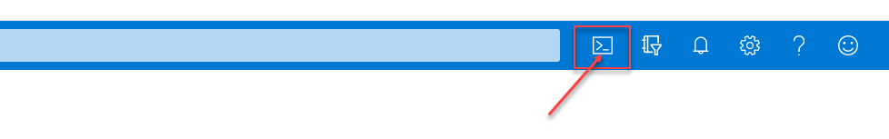
- Choose PowerShell –
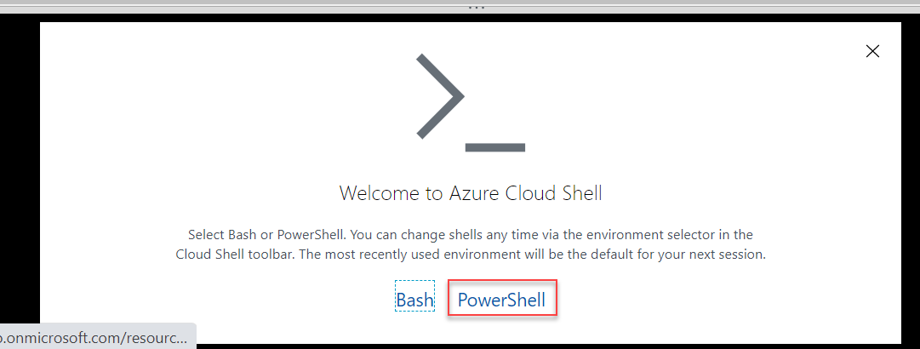

- Create a new storage account by selecting ‘Create Storage’ OR use an existing storage account by selecting ‘Show advanced setting’.
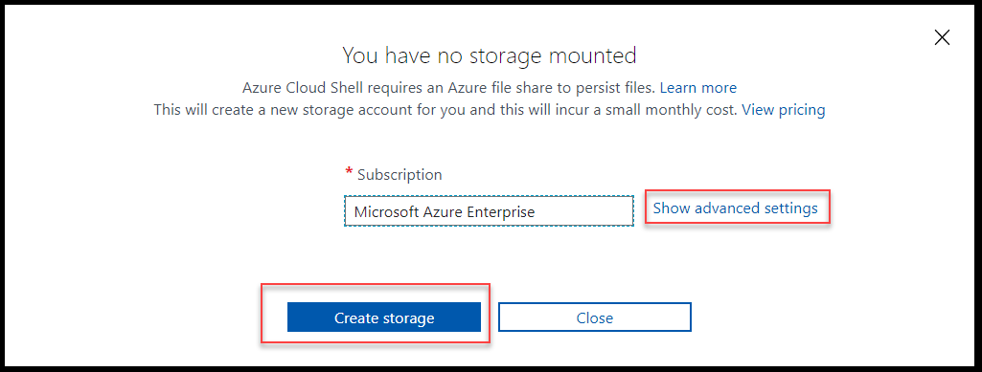
- Create New Storage: Click on ‘Create storage’ and the Azure CloudShell will auto configure the storage account and load the CloudShell window.
- Using an existing storage account: Click on ‘Show advanced settings’ and navigate through the settings to select any existing storage account.

Step II: Transfer ACTT script( ACTTAzure.ps1) on Azure CloudShell-
- Navigate to Clouddrive and create a new directory using ‘mkdir’ command and change your directory to newly created directory as shown below

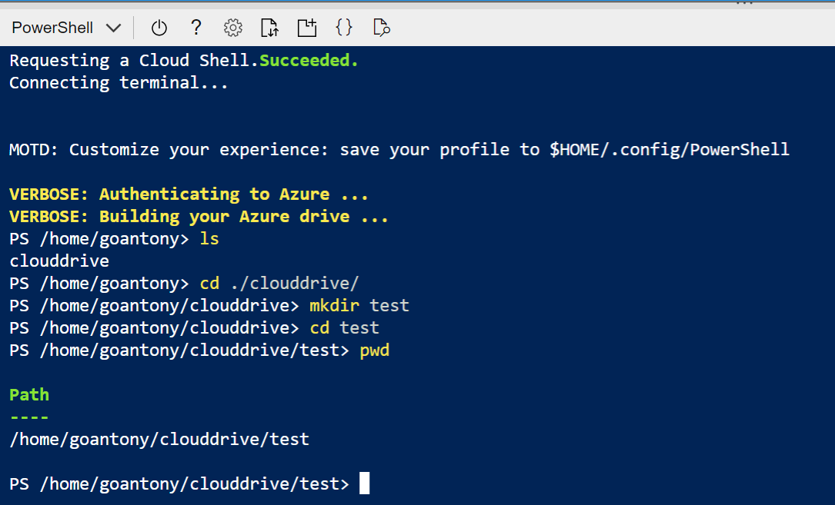

- Click on Upload as shown below and upload the ACTT Azure script.

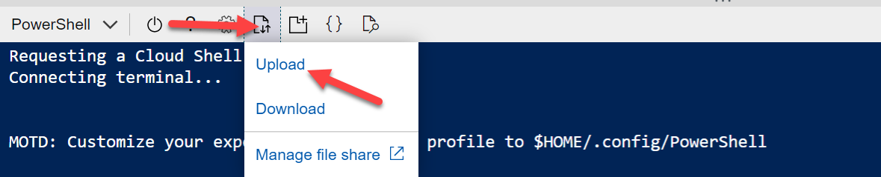

- Run the below command to move the script to the newly created folder under clouddrive-
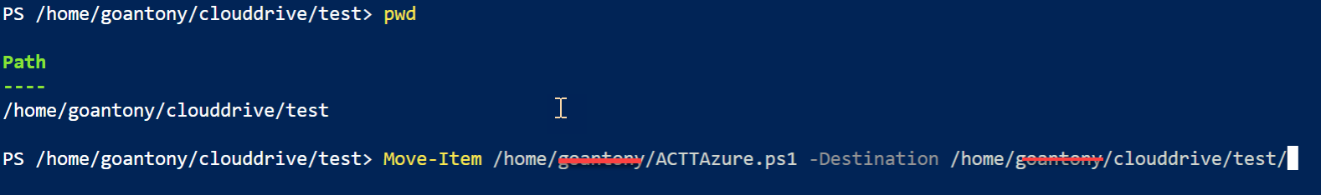

- Run the below command on the prompt-
Connect-AzureAD

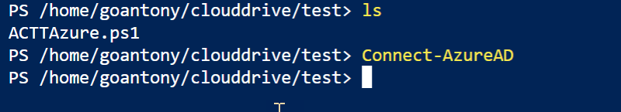

- Execute the script from current location as shown below-

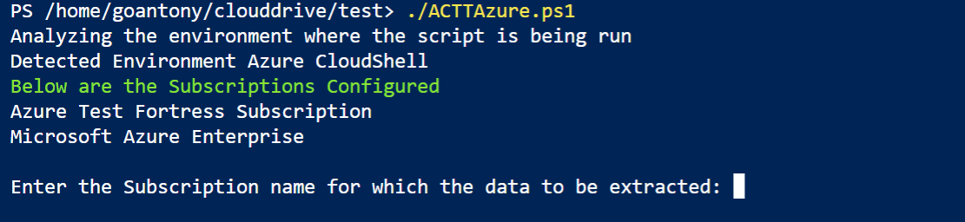

- Choosing the subscription:
Copy and paste the subscription name to begin the extraction.

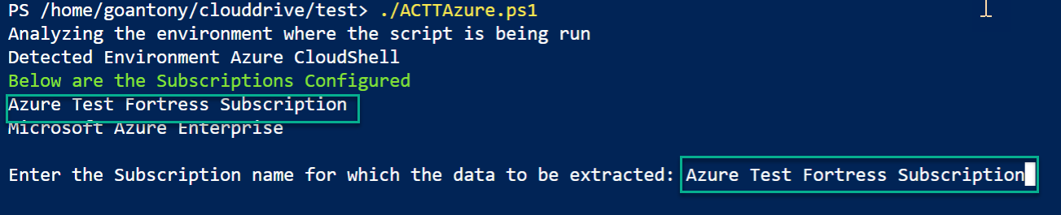

Note: Only one subscription need to be selected for the extracion. If mulitple subscription in scope for extraction. Copy the extracted output of 1st subscription to host machine, remove the files from the cloudshell and start a fresh extraction for the 2nd subscription.

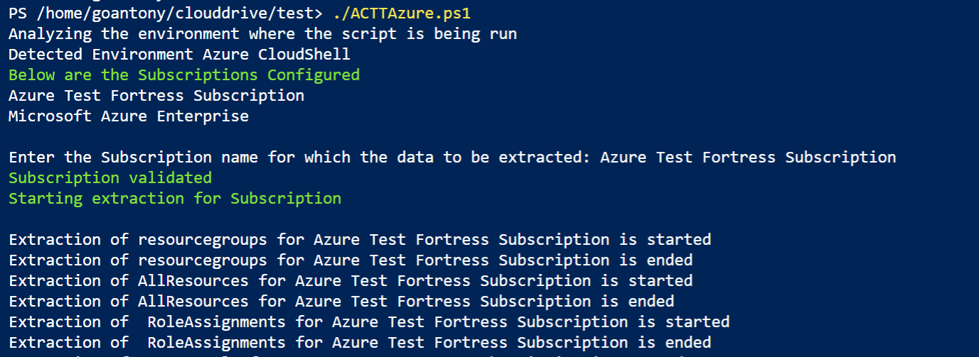

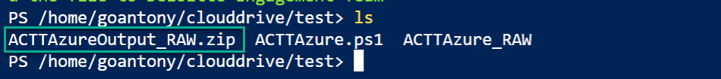

The Output file is ACTTAuzreOutput_RAW.zip

Step III:
Extraction of Azuregroupmembers.ps1

- Copy the script to the Cloud Console
- Run the below command on the prompt-
Connect-AzureAD
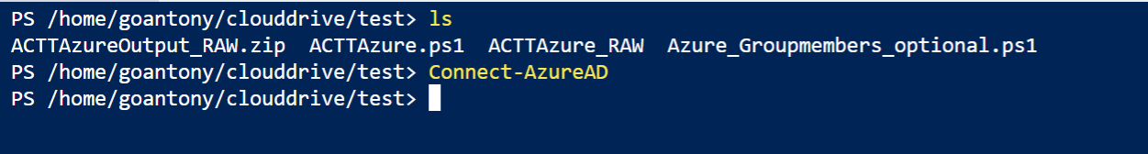

- Execute the command ./Azure_Groupmembers_optional.ps1
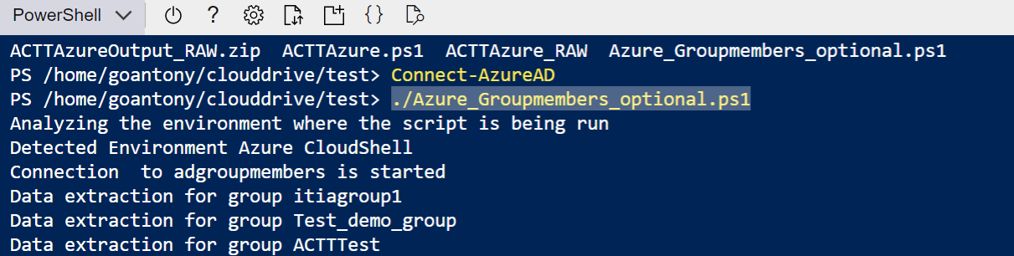
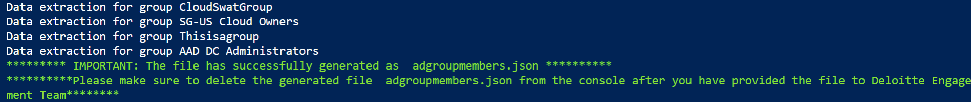

- Output file adgroupmembers.json

Step IV: Send the files to your Deloitte contact
The script will attempt to compress the files into a zip file. If this happened successfully, you will find the relevant ZIP file created on the same location where the script resides.
You can download the zip by
- Click on download button as shown below-
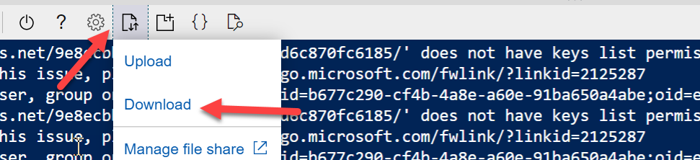

- Provide the location of the created zip file and click download-
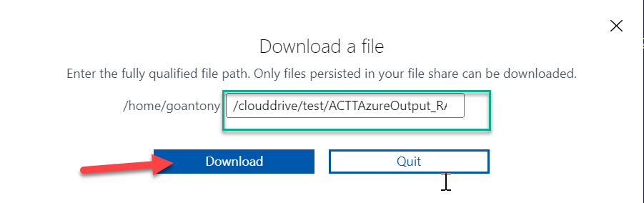
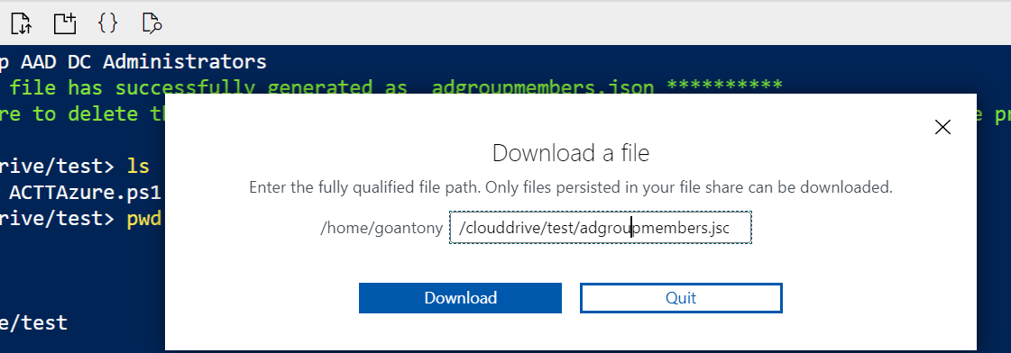

- Kindly share the ACTTAuzreOutput_RAW.zip and adgroupmembers.json file the deloitte practitioner.

Method 2: Extraction from a Windows Server (Optional Method).

Pre- Requisites:
- Azure CLI need to be Installed.
Note: If CLI need to be installed please use the below link

https://azcliprod.blob.core.windows.net/msi/azure-cli-2.48.1.msi

- Azure-AD Modules to be present
Note: If AD Module to be installed
- Open the PowerShell in the Admin Mode
- Install-Module AzureAD
- Import-Module AzureAD
- After the extraction remove the module Uninstall-Module AzureAD

Step 1: Copy the extract script ACTTAzure.ps1 to the Windows Server.

Step 2: Open the PowerShell and to the file location where the script is copied.

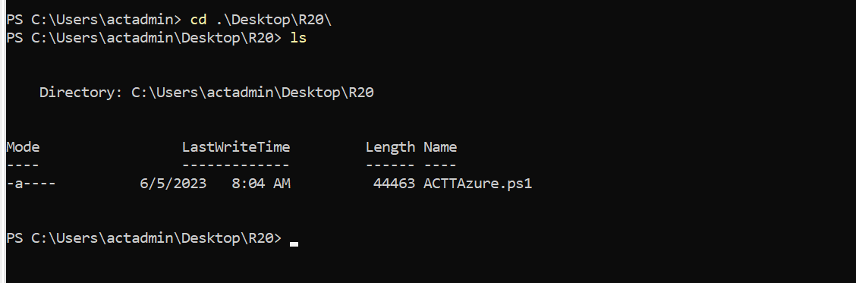

Step 3: Execute command Connect AzureAD

Provide the login credentials.

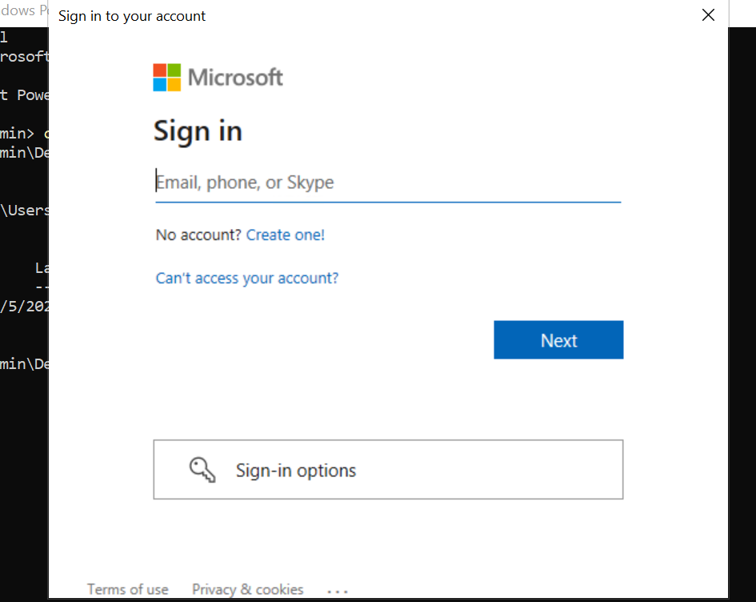

Step4: Execute the script .\ACTTAzure.ps1 and provide the credentilas for az login command and then choose the subscription for the extraction.

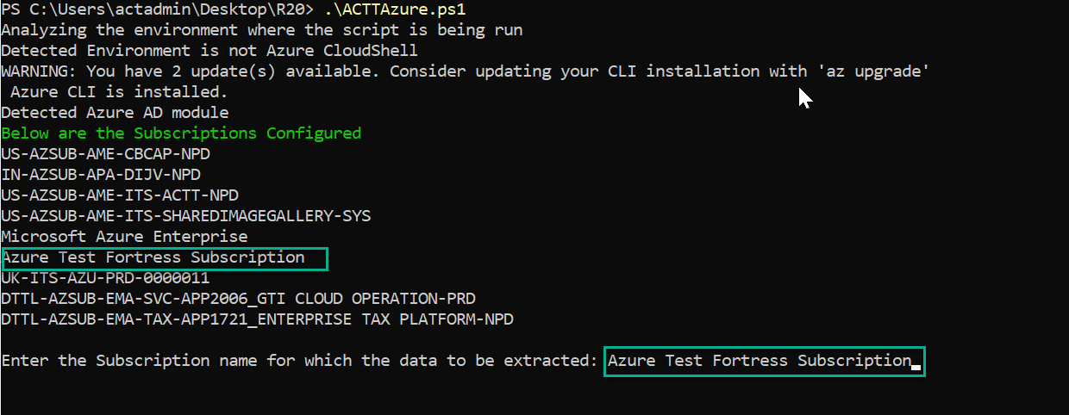

Note: Only one subscription need to be selected for the extracion. If mulitple subscription in scope for extraction. Copy the extracted output of 1st subscription to host machine, remove the files from the cloudshell and start a fresh extraction for the 2nd subscription.

Step 5: After the successful extraciton the output file is created.
The Output file is ACTTAuzreOutput_RAW.zip

Step 6: Extraction of AzureAD Group Members

- Copy the file Azure_Groupmembers_optional.ps1
- Execute command Connect AzureAD
Provide the login credentials.

- Execute the below command to start groupmembers extraction .\Azure_Groupmembers_optional.ps1

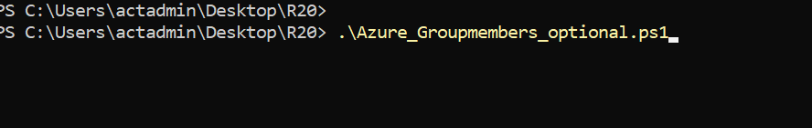

- Kindly share the ACTTAuzreOutput_RAW.zip and adgroupmembers.json file the deloitte practitioner.

